

**READ THIS FIRST**







**PART A – INTRODUCTION**

**1. LEGAL NAME OF APPLICANT ORGANIZATION: Rubicon Analytics and Development, LLC**

CONTACT PERSON: **Michael Turtora** TITLE: **Organizing Committee Chair**

ADDRESS: **326 W. Crest Ave, Tampa, FL 33603**

DAYTIME PHONE: **904 540 0231** FAX: _________________ EMAIL: **mjturtora@gmail.com**

**2. EVENT NAME:** Hack Zika 2017

**3. EVENT DATE(S):** September 29 - October 7, 2017

**4**. **LOCATION/ADDRESS** (if applicable): Tampa Bay WaVE, 500 E. Kennedy Blvd, Tampa, FL 33602

□ UNINCORPORATED COUNTY □ CITY OF PLANT CITY x CITY OF TAMPA □ CITY OF TEMPLE TERRACE

**5. NUMBER OF EXPECTED PARTICIPANTS:** 100

**6. EXPECTED PARTICIPANT OR TARGET PROFILE (ENTREPRENEUR, EXECUTIVE, VENTURE CAPITAL, MINORITY, WOMEN, ETC.):** Students, Entrepreneurs, Executives, event open to all.

**7. EXPECTED TOTAL COST OF EVENT OR INDUSTRY PROMOTION (Also, provide a breakdown of the event by major category expense and attach):** $9,000

**8. GRANT AMOUNT REQUESTED ($20,000 maximum):** $2,000

**9. GEOGRAPHIC REACH OF IMPACT (for example – national conference, regional meeting, etc.):**

INTERNATIONAL □ NATIONAL □ STATEWIDE X LOCAL (TAMPA BAY) □

|  |
| --- |
| **10. IS THIS A RECURRING EVENT?** Yes. Gave this year’s name of C4TB annual hackathon.  **IF YES:**  **10a. HOW OFTEN DOES THE EVENT OCCUR?** Annually or Biannually    **10b. WHEN WAS THE INITIAL EVENT?** 2013?  **10c. DO YOU PLAN TO CONTINUE THE EVENT IN THE FUTURE?** YES |

**FOR THE FOLLOWING QUESTIONS, PLEASE ATTACH NARRIATIVE RESPONSES TO APPLICATION**

## **11. BRIEFLY DESCRIBE THE EVENT OR INDUSTRY PROMOTION (**PLEASE LIMIT RESPONSE TO TWO PARAGRAPHS).

**PART B – REVIEW CRITERIA**

**DESCRIBE HOW THE EVENT MEETS AND/OR EXCEEDS EACH OF THE APPLICABLE REVIEW CRITERIA AS THEY APPLY. EACH REVIEW CRITERIA MUST BE ADDRESSED AND ARE DESCRIBED IN GREATER DETAIL IN THE EDI2 PROGRAM POLICY DOCUMENT.**

**1. DESCRIPTION:** DESCRIBEHOW THE EVENT (i) DRIVES THE GROWTH OF TECHNOLOGY AND INNOVATION START-UPS AND SMALL BUSINESSES IN HILLSBOROUGH COUNTY; (ii) SUPPORTS THE PURPOSE AND MEET THE OBJECTIVES OF EDI2; and (iii) SUPPORTS MINORITIES, WOMEN AND/OR VETERANS WITH THEIR ENTREPRENEURIAL SUCCESS.

**2. LEVERAGING:** DESCRIBE HOW THE PROJECT (i) LEVERAGES PRIVATE SECTOR DOLLARS IN TERMS OF FINANCING, EXPERTISE AND NETWORKING; and (ii)DEMONSTRATES A COLLABORATIVE AND SYNERGISTIC APPROACH

**3.** **PERFORMANCE EVALUATION/METRICS.** PROVIDE APPROPRIATE CRITERIA AND MILESTONES FOR DETERMINING/ MEASURING THE SUCCESS OF THE EVENT. DEFINE RELEVANT OUTCOME INDICATORS AND TARGETS DURING AND AFTER THE EVENT (SUCH NUMBER OF EVENT ATTENDEES, ATTENDEE PROFILES, MEDIA COVERAGE, GROWTH IN PARTICIPATION OVER PREVIOUS YEARS, HOTEL NIGHTS, NEW START-UPS FORMED, NUMBER OF JOBS CREATED AS A RESULT OF THE EVENT, AMOUNT OF PROVATE CAPITAL INVESTMENT RECEIVED AS A RESULT OF THE EVENT.)

**4. ECONOMIC DEVELOPMENT IMPACT:** DESCRIBE HOW THE EVENT DEMONSTRATES A WELL-THOUGHT OUT IDEA AND MODEL THAT HAS THE POTENTIAL TO BE SUSTAINABLE AND GENERATE ECONOMIC DEVELOPMENT; CREATES PERMANENT LOCAL JOBS AND POTENTIAL FOR SUSTAINED ECONOMIC IMPACT AND GROWTH; GENERATES LOCAL BUSINESS; ADDS VALUE TO THE LOCAL ECONOMY.

**5.** **QUALITY OF TEAM:** DESCRIBE THE QUALIFICATIONS, TRACK RECORD, AND ABILITY OF THE APPLICANT AND PROFESSIONALS COMPOSING THE EVENT TEAM TO SUCCESSFULLY EXECUTE THE EVENT.

**PART C – ATTACHMENTS**

**ATTACH ANY COLLATERAL/PROMOTIONAL MATERIAL, EVENT AGENDA, TESTIMONIALS, PAST EVENT AGENDAS IF APPLICABLE, AND OTHER INFORMATION THAT WILL ASSIST STAFF IN EVALUATING THE APPLICATION.**

**APPLICANT CERTIFICATION**

I agree to comply with all requirements of the Hillsborough County Economic Development Innovation Initiative, that any funds received as a result of the application will be used only for purposes set forth herein, that I am authorized to submit this application on behalf of my organization, and that the statements herein are true, complete and accurate to the best of my knowledge. I also certify that I have read and understand the EDI2 program description, policy and guidelines. I acknowledge that staff strongly encourages applicants to have a pre-application meeting.

**_______________________________________ _________________________**

Signed Name Date

**_______________________________________**

Printed Name

**<RAD/>**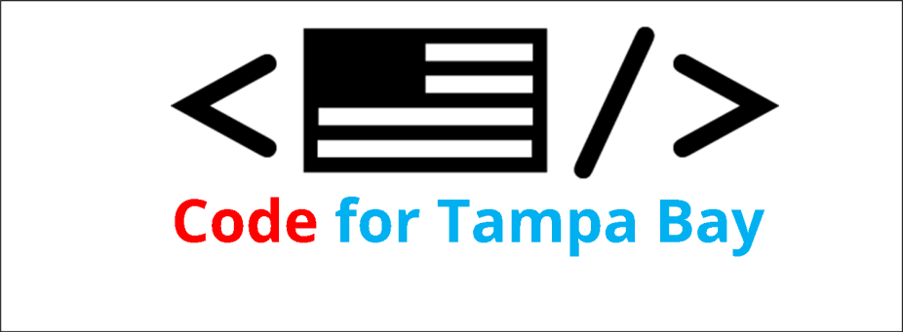

**Rubicon Analytics & Development LLC**

**326 W. Crest Ave.**

**Tampa, FL 33603**

**Hillsborough County**

**Economic Development Innovation Initiative Application**

**Events and Industry Promotion Initiatives**

**11. BRIEFLY DESCRIBE THE EVENT OR INDUSTRY PROMOTION (PLEASE LIMIT RESPONSE TO TWO PARAGRAPHS).**

**Hack Zika 2017** will be this year’s fall hackathon sponsored by **Code for Tampa Bay Brigade (C4TB)**. C4TB is a local chapter of Code for America, one of many in the state of Florida. As a Code for America Brigade, C4TB is an organizing force for local civic engagement - part of a national network of civic-minded volunteers who contribute their skills toward using the web as a platform for local government and community service. **Hack Zika 2017** will focus on creating solutions in support of Hillsborough County Mosquito Control in order to lower the risk posed by the Zika virus. We are developing a suite of hackathon challenges based on Mosquito Control’s “wish list” of applications they had previously determined they need.

Code for America organizes a “National Day of Civic Hacking” (NDCH) typically held in June. This year, the NDCH will be held September 23rd. Because of Hurricane Irma, Florida Brigades have rescheuled their Day of Civic Hacking making it a Florida event. **Hack Zika 2017**, will unite technologists, entrepreneurs, developers and other citizens while using open data to improve our communities and the governments that serve them.

**PART B – REVIEW CRITERIA**

**DESCRIBE HOW THE EVENT/PROMOTION MEETS AND/OR EXCEEDS EACH OF THE APPLICABLE REVIEW CRITERIA AS THEY APPLY. EACH REVIEW CRITERIA MUST BE ADDRESSED BELOW.**

**1. DESCRIPTION:** DESCRIBEHOW THE EVENT (i) DRIVES THE GROWTH OF TECHNOLOGY AND INNOVATION START-UPS AND SMALL BUSINESSES IN HILLSBOROUGH COUNTY; (ii) SUPPORTS THE PURPOSE AND MEET THE OBJECTIVES OF EDI2; and (iii) SUPPORTS MINORITIES, WOMEN AND/OR VETERANS WITH THEIR ENTREPRENEURIAL SUCCESS.

Hack Zika 2017 will drive the growth of technology and innovation by bringing together local business and technology professionals, students, and professors interested in civic engagement, providing a positive environment for networking and collaboration. This effort will help strengthen Tampa Bay’s technology community by bringing together a diverse group of people for the common good of Tampa Bay. The event is open to all, and minorities, women, and veterans are encouraged to participate, join teams, and compete.

**2. LEVERAGING: DESCRIBE HOW THE PROJECT (i) LEVERAGES PRIVATE SECTOR DOLLARS IN TERMS OF FINANCING, EXPERTISE AND NETWORKING; and (ii) DEMONSTRATES A COLLABORATIVE AND SYNERGISTIC APPROACH**

Hack Zika 2017, hosted by Tampa Bay WaVE, a leading Tampa business start-up incubator, leverages the private sector and Tampa’s technical and creative resources by showcasing the best that Tampa has to offer, in the service of a better Tampa community. Our local event is necessarily a collaborative endeavor, bringing together area professionals and Hillsborough government to work together on solutions for improving services and resources for residents through shared skills. The event has been widely advertised and may well attract participants and support from national brands (IBM, Microsoft, HomeAdvisor).

**3. PERFORMANCE EVALUATION/METRICS. PROVIDE APPROPRIATE CRITERIA AND MILESTONES FOR DETERMINING/MEASURING THE SUCCESS OF THE EVENT/PROMOTION. DEFINE RELEVANT OUTCOME INDICATORS AND TARGETS DURING AND AFTER THE EVENT/PROMOTION (SUCH NUMBER OF EVENT ATTENDEES, ATTENDEE PROFILES, MEDIA COVERAGE, GROWTH IN PARTICIPATION OVER PREVIOUS YEARS, HOTEL NIGHTS, NEW START-UPS FORMED)**

There have been several previous hackathons in Hillsborough County focused on civic hacking, both with and without participation by C4TB. Attendance is typically 50 to 100 people ranging from students and professors to technology entrepreneurs; as well as community leaders, government employees, and members of the press. We are using Eventbrite for registration this year which will allow us to survey attendees as to their roles and interests. A post registration survey will also be sent to those that request help forming teams during the kick-off time period.

Jenny Dean, of channel 10 news (WTSP) may cover the event. 83 Degrees Media will be covering the event and other print media outlets have been invited (Creative Loafing).

While the event itself will produce tangible economic benefits, the true measure of a hackathon’s success is the implementation of its products. The focus of last year’s hackathon was to develop applications in support of the Tampa Hillsborough Homeless Initiative (THHI). Antonio Byrd (THHI COO) reports that the online “point-in-time” homeless survey was delayed because THHI’s proprietary database vendor (Bowman Systems) was slow to provide the information the Accusoft team needed to deploy the application. Development continues however, and there is a good chance the system will be up and running for next year’s homeless survey.

As a recognized Code for America Brigade, C4TB is well positioned to provide long term metrics of efforts initiated at Hack Zika 2016 and to keep track of efforts that may spin off from projects developed during the event. Additionally, Eureka Factory, which lead event planning for Hack Tampa Bay 2015, and is also

involved this year, has organized well-respected events like ROBOTICON Tampa Bay and Gulf Coast MakerCon, and has a reliable track record for recording event statistics and measuring program growth.

**4. ECONOMIC DEVELOPMENT IMPACT: DESCRIBE HOW THE EVENT/INDUSTRY PROMOTION DEMONSTRATES A WELL-THOUGHT OUT IDEA AND MODEL THAT HAS THE POTENTIAL TO BE SUSTAINABLE AND GENERATE ECONOMIC DEVELOPMENT; CREATES PERMANENT LOCAL JOBS AND POTENTIAL FOR SUSTAINED ECONOMIC IMPACT AND GROWTH; GENERATES LOCAL BUSINESS; ADDS VALUE TO THE LOCAL ECONOMY. ‘**

Hackathons follow established protocols, and have proven themselves popular and sustainable, as well as a source of new community-minded app and software development. With the added value of being produced by an approved Code for America Brigade unit, Hack Zika 2017, has a greater potential to provide participants with spin off opportunities on developed apps and business solutions, and certainly brings added value to the local economy by helping improve government resources and civic solutions.

**5. QUALITY OF TEAM: DESCRIBE THE QUALIFICATIONS, TRACK RECORD, AND ABILITY OF THE APPLICANT AND PROFESSIONALS COMPOSING THE EVENT/PROMOTION TEAM TO SUCCESSFULLY EXECUTE THE EVENT/PROMOTION.**

The Hack Tampa Bay team includes professionals from a variety of technology and innovation sectors of Tampa Bay, with a proven track record of event and program production. Planning team members include:

* Terri Willingham, of Willingham Associates, LLC , developers of the John F. Germany makerspace, the Hive, and organizers of ROBOTICON Tampa Bay for the last two years, and Gulf Coast MakerCon,
* John Punzak, Sr. National Sales Director, State & Local Government / Education with Red Hat, an open source software development for enterprise IT, with a broad portfolio of products and services for commercial markets.
* Michael Turtora, of Rubicon Analytics and Development, LLC, a semi-retired tech entrepreneur with decades of experience in project management and data science. While serving the Federal Government as a statistical ecologist for the United States Geological Survey, he managed complex projects with high levels of public participation and volunteer support.
* Meg Comins, Loop Jr. Software Developer, SourceToad, a Tampa web development firm.

# **Hack Zika 2017 Budget**

|  |  |
| --- | --- |
| Items | Expense |
| Event shirts | $1,000 |
| Promotional materials (flyers,banners, signage) | $1,800 |
| Administrative | $500 |
| Food | $2,500 |
| Prizes | $1,000 |
| Venue | $2,200 |
| Total | $9,000 |

*As per EDI2 guidelines, food costs, and in-kind services will not be paid with EDI2 funds but dollar value of all expenses are listed here for reference to total event cost.*

**Letter of Support**

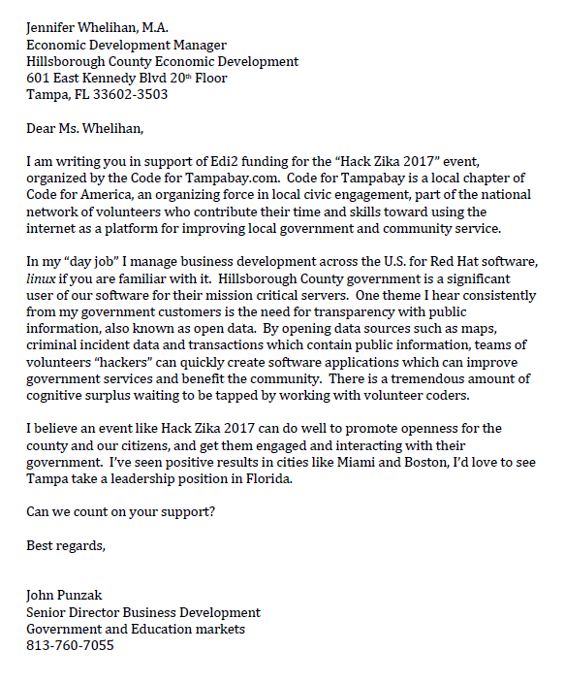

## **Event Flyer**

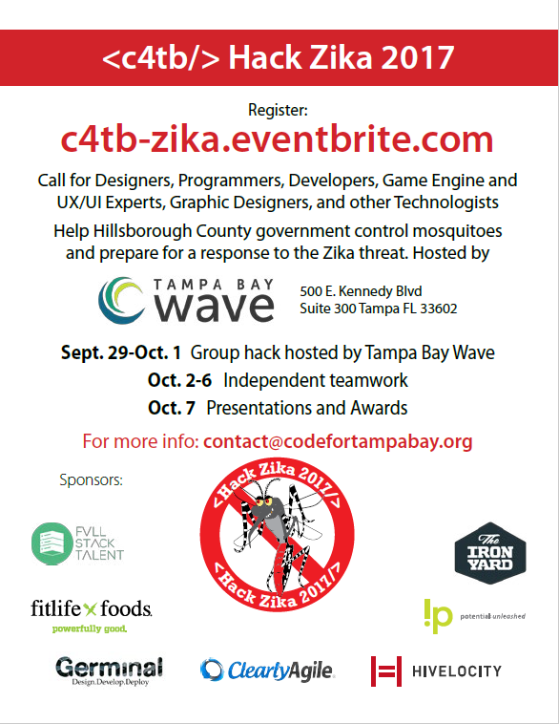

## **Sponsor Flyer**

## 

## **About Code for Tampa Bay**

